Introduction to Microcontrollers
Definition
An embedded microcontroller is a chip which has a computer processor with all its support functions (clock & reset), memory (both program and data), and I/O (including bus interface) built into the device. These built in functions minimize the need for external circuits and devices to be designed in the final application.

Types of Microcontroller
Creating applications for microcontrollers is completely different than any other development job in computing and electronics. In most other applications one probably have a number of subsystem and interfaces already available for his/her use. This is not the case with a microcontroller where one is responsible for –

- Power distribution
- System clocking
- Interface design and wiring
- System programming
- Application programming
- Device programming

Before selecting a particular device for an application, it’ s important to understand what the different options and features are and what they can mean with regard to developing application.

- Embedded Microcontroller
When all the hardware required to run the application is provided on the chip, it is refer to as an Embedded Microcontroller. All that is typically required to operate the device is power, reset, and a clock. Digital I/O pins are provided to allow interfacing with external devices.

- External Memory Microcontroller
Sometimes, the program memory is insufficient for an application or, during debug; a separate ROM (or even RAM) would make the work easier. Some microcontrollers including the 8051 allow the connection of external memory.

An external memory microcontroller seems to primarily differ from a microprocessor in the areas of built-in-peripheral features. These features could include memory device selection (avoiding the need for external address decoders or DRAM address multiplexers), timers, interrupt controllers, DMA, and I/O devices like serial ports.

Microcontroller Memory Types
There are number of different types of control store (Program Memory) that are available in different versions and different manufacturers’ 8051s. There is a fairly simple convention that is used to identify what type of control store a device has.

The following is the list of conventions used for 8X51-

“X” value Control Store Type
0 None
3 Mask ROM
7 EPROM
9 EEPROM/FLASH

The 89C51 microcontroller

The AT89C51 is a low-power, high-performance CMOS 8-bit microcomputer with 4K bytes of Flash programmable and erasable read only memory (PEROM). The device is manufactured using Phillips’s high-density nonvolatile memory technology and is compatible with the industry-standard MCS-51 instruction set and pin out. The on-chip Flash allows the program memory to be reprogrammed in-system or by a conventional nonvolatile memory programmer. By combining a versatile 8-bit CPU with Flash on a monolithic chip, the Phillips AT89C51 is a powerful microcomputer which provides a highly-flexible and cost-effective solution to many embedded control applications.

The AT89C51 is designed with static logic for operation down to zero frequency and supports two Software selectable power saving modes. The Idle Mode stops the CPU while allowing the RAM, timer/counters, serial port and interrupt system to continue functioning. The Power-down Mode saves the RAM contents but freezes the oscillator disabling all other chip functions until the next Hardware reset.

Features of 89C51

Following is the features of 89C51 microcontroller as per the datasheet given by Phillips-

- Compatible with MCS-51™ Products
- 4K Bytes of In-System Reprogrammable Flash Memory Endurance: 1,000 Write/Erase Cycles
- Fully Static Operation: 0 Hz to 24 MHz
- Three-level Program Memory Lock
- 128 x 8-bit Internal RAM
- 32 Programmable I/O Lines
- Two 16-bit Timer/Counters
- Six Interrupt Sources
- Programmable Serial Channel
- Low-power Idle and Power-down Modes

Pin Diagram of 89C51:
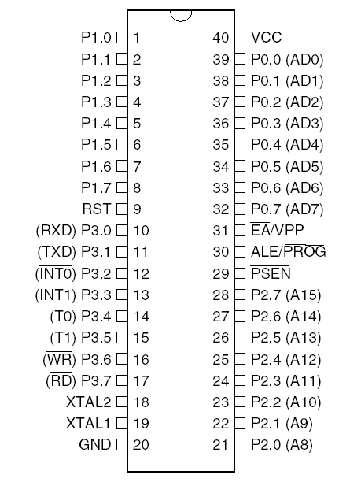

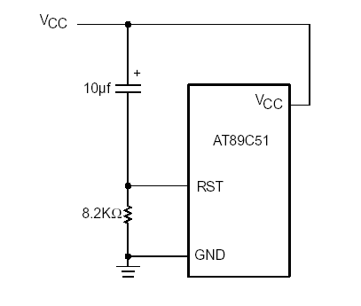
Basic Reset Ckt.

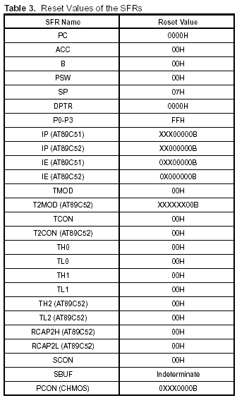
Power On Reset Value.

Architecture of 89C51
Block Diagram 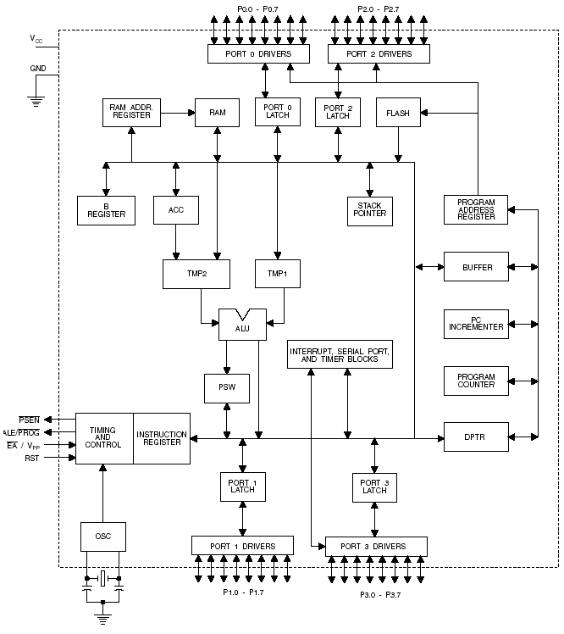
Brief Description
The AT89C51 is a low-power, high-performance CMOS 8-bit microcomputer with 4K bytes of Flash programmable and erasable read only memory (PEROM). The device is manufactured using Phillips’s high-density nonvolatile memory technology and is compatible with the industry-standard MCS-51 instruction set and pinout. The on-chip Flash allows the program memory to be reprogrammed in-system or by a conventional nonvolatile memory programmer. By combining a versatile 8-bit CPU with Flash on a monolithic chip, the Phillips AT89C51 is a powerful microcomputer which provides a highly-flexible and cost-effective solution to many embedded control applications.

Pin Description
- VCC
Supply voltage.
- GND
Ground.
- Port 0
Port 0 is an 8-bit open-drain bi-directional I/O port. As an output port, each pin can sink eight TTL inputs. When 1s are written to port 0 pins, the pins can be used as high impedance inputs. Port 0 may also be configured to be the multiplexed low order address/data bus during accesses to external program and data memory. In this mode P0 has internal pull-ups. Port 0 also receives the code bytes during Flash programming, and outputs the code bytes during program verification. External pull-ups are required during program verification.

- Port 1
Port 1 is an 8-bit bi-directional I/O port with internal pull-ups. The Port 1 output buffers can sink/source four TTL inputs. When 1s are written to Port 1 pins they are pulled high by the internal pull-ups and can be used as inputs. As inputs, Port 1 pins that are externally being pulled low will source current (IIL) because of the internal pull-ups. Port 1 also receives the low-order address bytes during Flash programming and verification.

- Port 2
Port 2 is an 8-bit bi-directional I/O port with internal pull-ups. The Port 2 output buffers can sink/source four TTL inputs. When 1s are written to Port 2 pins they are pulled high by the internal pull-ups and can be used as inputs. As inputs, Port 2 pins that are externally being pulled low will source current (IIL) because of the internal pull-ups. Port 2 emits the high-order address byte during fetches from external program memory and during accesses to external data memory that uses 16-bit addresses (MOVX @ DPTR). In this application, it uses strong internal pull-ups when emitting 1s. During accesses to external data memory that uses 8-bit addresses (MOVX @ RI), Port 2 emits the contents of the P2 Special Function Register.
Port 2 also receives the high-order address bits and some control signals during Flash programming and verification.

- Port 3
Port 3 is an 8-bit bi-directional I/O port with internal pull-ups. The Port 3 output buffers can sink/source four TTL inputs. When 1s are written to Port 3 pins they are pulled high by the internal pull-ups and can be used as inputs. As inputs, Port 3 pins that are externally being pulled low will source Current (IIL) because of the pull-ups. Port 3 also serves the functions of various special features of the AT89C51 as listed below:

Port Pin Alternate Functions –

P3.0 RXD (serial input port)
P3.1 TXD (serial output port)
P3.2 INT0 (external interrupt 0)
P3.3 INT1 (external interrupt 1)
P3.4 T0 (timer 0 external input)
P3.5 T1 (timer 1 external input)
P3.6 WR (external data memory write strobe)
P3.7 RD (external data memory read strobe)

Port 3 also receives some control signals for Flash programming and verification.

- RST
Reset input. A high on this pin for two machine cycles while the oscillator is running resets the device.

- ALE/PROG
Address Latch Enable output pulse for latching the low byte of the address during accesses to external memory. This pin is also the program pulse input (PROG) during Flash programming. In normal operation ALE is emitted at a constant rate of 1/6 the oscillator frequency, and may be used for external timing or clocking purposes. Note, however, that one ALE pulse is skipped during each access to external Data Memory. If desired, ALE operation can be disabled by setting bit 0 of SFR location 8EH. With the bit set, ALE is active only during a MOVX or MOVC instruction. Otherwise, the pin is weakly pulled high. Setting the ALE-disable bit has no effect if the microcontroller is in external execution mode.

- PSEN
Program Store Enable is the read strobe to external program memory. When the AT89C51 is executing code from external program memory, PSEN is activated twice each machine cycle, except that two PSEN activations are skipped during each access to external data memory.

- EA/VPP
External Access Enable. EA must be strapped to GND in order to enable the device to fetch code from external program memory locations starting at 0000H up to FFFFH. Note, however, that if lock bit 1 is programmed, EA will be internally latched on reset. EA should be strapped to VCC for internal program executions. This pin also receives the 12-volt programming enable voltage (VPP) during Flash programming, for parts that require 12-volt VPP.
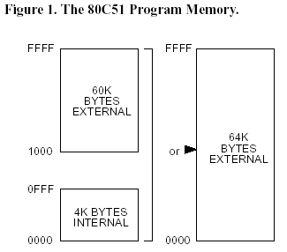
- XTAL1
Input to the inverting oscillator amplifier and input to the internal clock operating circuit.
- XTAL2
Output from the inverting oscillator amplifier.
Memory Organization

Program Memory

The TEMIC C51 Microcontroller Family has separate address spaces for program Memory and Data Memory. The program memory can be up to 64 K bytes long. The lower 4 K for the 80C51 (8 K for the 80C52, 16 K for the 83 C154 and 32 K for the 83C154D) may reside on chip.

Data Memory

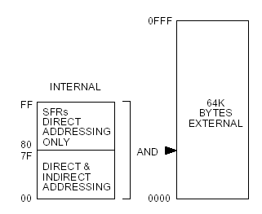
The C51 Microcontroller Family can address up to 64 K bytes of Data Memory to the chip. The “MOVX” instruction is used to access the external data memory (refer to the C51 instruction set, in this chapter, for detailed description of instructions). The 80C51 has 128 bytes of on-chip-RAM (256 bytes in the 80C52, 83C154 and 83C154D) plus a number of Special Function Registers (SFR). The lower 128 bytes of RAM can be accessed either by direct addressing (MOV data addr). or by indirect addressing (MOV @Ri).

- Watchdog Timer (One-time Enabled with Reset-out):
The WDT is intended as a recovery method in situations where the CPU may be subjected to software upsets. The WDT consists of a 14-bit counter and the Watchdog Timer Reset (WDTRST) SFR. The WDT is defaulted to disable from exiting reset. To enable the WDT, a user must write 01EH and 0E1H in sequence to the WDTRST register (SFR location 0A6H). When the WDT is enabled, it will increment every machine cycle while the oscillator is running. The WDT timeout period is dependent on the external clock frequency. There is no way to disable the WDT except through reset (either hardware reset or WDT overflow reset). When WDT overflows, it will drive an output RESET HIGH pulse at the RST pin.

1. Using the WDT
To enable the WDT, a user must write 01EH and 0E1H in sequence to the WDTRST register (SFR location 0A6H). When the WDT is enabled, the user needs to service it by writing 01EH and 0E1H to WDTRST to avoid a WDT overflow. The 14-bit counter overflows when it reaches 16383 (3FFFH), and this will reset the device. When the WDT is enabled, it will increment every machine cycle while the oscillator is running. This means the user must reset the WDT at least every 16383 machine cycles. To reset the WDT the user must write 01EH and 0E1H to WDTRST. WDTRST is a write-only register. The WDT counter cannot be read or written. When WDT overflows, it will generate an output RESET pulse at the RST pin. The RESET pulse duration is 98xTOSC, where TOSC = 1/FOSC. To make the best use of the WDT, it should be serviced in those sections of code that will periodically be executed within the time required to prevent a WDT reset.

2. WDT during Power-down and Idle
In Power-down mode the oscillator stops, which means the WDT also stops. While in Power down mode, the user does not need to service the WDT. There are two methods of exiting Power-down mode: by a hardware reset or via a level-activated external interrupt which is enabled prior to entering Power-down mode. When Power-down is exited with hardware reset, servicing the WDT should occur as it normally does whenever the AT89S52 is reset. Exiting Power-down with an interrupt is significantly different. The interrupt is held low long enough for the oscillator to stabilize. When the interrupt is brought high, the interrupt is serviced. To prevent the WDT from resetting the device while the interrupt pin is held low, the WDT is not started until the interrupt is pulled high. It is suggested that the WDT be reset during the interrupt service for the interrupt used to exit Power-down mode. To ensure that the WDT does not overflow within a few states of exiting Power-down, it is best to reset the WDT just before entering Power-down mode. Before going into the IDLE mode, the WDIDLE bit in SFR AUXR is used to determine whether the WDT continues to count if enabled. The WDT keeps counting during IDLE (WDIDLE bit = 0) as the default state. To prevent the WDT from resetting the AT89S52 while in IDLE mode, the user should always set up a timer that will periodically exit IDLE, service the WDT, and reenter IDLE mode. With WDIDLE bit enabled, the WDT will stop to count in IDLE mode and resumes the count upon exit from IDLE.

- UART:
The UART in the AT89S52 operates the same way as the UART in the AT89C51 and AT89C52.

- Timer 0 and 1:
Timer 0 and Timer 1 in the AT89S52 operate the same way as Timer 0 and Timer 1 in the AT89C51 and AT89C52.

- Timer 2:
Timer 2 is a 16-bit Timer/Counter that can operate as either a timer or an event counter. The type of operation is selected by bit C/T2 in the SFR T2CON. Timer 2 has three operating modes: capture, auto-reload (up or down counting), and baud rate generator. The modes are selected by bits in T2CON, as shown in below table. Timer 2 consists of two 8-bit registers, TH2 and TL2. In the Timer function, the TL2 register is incremented every machine cycle. Since a machine cycle consists of 12 oscillator periods, the count rate is 1/12 of the oscillator frequency.
In the Counter function, the register is incremented in response to a 1-to-0 transition at its corresponding external input pin, T2. In this function, the external input is sampled during S5P2 of every machine cycle. When the samples show a high in one cycle and a low in the next cycle, the count is incremented. The new count value appears in the register during S3P1 of the cycle following the one in which the transition was detected. Since two machine cycles (24 oscillator periods) are required to recognize a 1-to-0 transition, the maximum count rate is 1/24 of the oscillator frequency. To ensure that a given level is sampled at least once before it changes, the level should be held for at least one full machine cycle.

Timer 2 Operating mode
RCLK+TCLK | CP/RL2 | TR2 | Mode
0 | 0 | 1 | 16-bit Auto-reload
0 | 1 | 1 | 16-bit Capture
1 | X | 1 | Baud Rate Generator
X | X | 0 | (off)

1. Capture Mode
In the capture mode, two options are selected by bit EXEN2 in T2CON. If EXEN2 = 0, Timer 2 is a 16-bit timer or counter which upon overflow sets bit TF2 in T2CON. This bit can then be used to generate an interrupt. If EXEN2 = 1, Timer 2 performs the same operation, but a 1-to-0 transition at external input T2EX also causes the current value in TH2 and TL2 to be captured into RCAP2H and RCAP2L, respectively. In addition, the transition at T2EX causes bit EXF2 in T2CON to be set. The EXF2 bit, like TF2, can generate an interrupt.

2. Auto-reload (Up or Down Counter)
Timer 2 can be programmed to count up or down when configured in its 16-bit auto-reload mode. This feature is invoked by the DCEN (Down Counter Enable) bit located in the SFR T2MOD. Upon reset, the DCEN bit is set to 0 so that timer 2 will default to count up. When DCEN is set, Timer 2 can count up or down, depending on the value of the T2EX pin.

Oscillator Characteristics:
XTAL1 and XTAL2 are the input and output, respectively, of an inverting amplifier that can be configured for use as an on-chip oscillator. Either a quartz crystal or ceramic resonator may be used. To drive the device from an external clock source, XTAL2 should be left unconnected while XTAL1 is driven. There are no requirements on the duty cycle of the external clock signal, since the input to the internal clocking circuitry is through a divide-by-two flip-flop, but minimum and maximum voltage high and low time specifications must be observed.

Interrupts:
The AT89S52 has a total of six interrupt vectors: two external interrupts (INT0 and INT1), three timer interrupts (Timers 0, 1, 2) and the serial port interrupt. Each of these interrupt sources can be individually enabled or disabled by setting or clearing a bit in Special Function Register IE. IE also contains a global disable bit, EA, which disables all interrupts at once. Note that Table shows that bit position IE.6 is unimplemented. User software should not write a 1 to this bit position, since it may be used in future AT89 products. Timer 2 interrupt is generated by the logical OR of bits TF2 and EXF2 in register T2CON. Neither of these flags is cleared by hardware when the service routine is vectored to. In fact, the service routine may have to determine whether it was TF2 or EXF2 that generated the interrupt, and that bit will have to be cleared in software. The Timer 0 and Timer 1 flags, TF0 and TF1, are set at S5P2 of the cycle in which the timers overflow. The values are then polled by the circuitry in the next cycle. However, the Timer 2 flag, TF2, is set at S2P2 and is polled in the same cycle in which the timer overflows.

Table: Interrupt Enable (IE) register

(MSB) (LSB)
EA | - | ET2 | ES | ET1 | EX1 | ET0 | EX0

1= Enables the interrupt
0= Disables the interrupt

Symbol | Position | Function
EA | IE.7 | Disables all interrupts. If EA = 0, no interrupt is acknowledged. If EA = 1, each interrupt source is individually enabled or disabled by setting or clearing its enable bit.
- | IE.6 | Reserved.
ET2 | IE.5 | Timer 2 interrupt enable bit.
ES | IE.4 | Serial Port interrupt enable bit.
ET1 | IE.3 | Timer 1 interrupt enable bit.
EX1 | IE.2 | External interrupt 1 enable bit.
ET0 | IE.1 | Timer 0 interrupt enable bit.
EX0 | IE.0 | External interrupt 0 enable bit.
Idle Mode:
In idle mode, the CPU puts itself to sleep while all the on-chip peripherals remain active. The mode is invoked by software. The content of the on-chip RAM and all the special functions registers remain unchanged during this mode. The idle mode can be terminated by any enabled interrupt or by a hardware reset. Note that when idle mode is terminated by a hardware reset, the device normally resumes program execution from where it left off, up to two machine cycles before the internal reset algorithm takes control. On-chip hardware inhibits access to internal RAM in this event, but access to the port pins is not inhibited. To eliminate the possibility of an unexpected write to a port pin when idle mode is terminated by a reset, the instruction following the one that invokes idle mode should not write to a port pin or to external memory.

Power-down Mode:
In the Power-down mode, the oscillator is stopped, and the instruction that invokes Power-down is the last instruction executed. The on-chip RAM and Special Function Registers retain their values until the Power-down mode is terminated. Exit from Power-down mode can be initiated either by a hardware reset or by an enabled external interrupt. Reset redefines the SFRs but does not change the on-chip RAM. The reset should not be activated before VCC is restored to its normal operating level and must be held active long enough to allow the oscillator to restart and stabilize.

Status of External Pins during Idle and Power-down Modes:

Mode | Program Memory | ALE |  | Port 0 | Port 1 | Port 2 | Port 3
Idle | Internal | 1 | 1 | Data | Data | Data | Data
Idle | External | 1 | 1 | Float | Data | Address | Data
Power-down | Internal | 0 | 0 | Data | Data | Data | Data
Power-down | External | 0 | 0 | Float | Data | Data | Data

Absolute maximum Rating:

- Operating temp.: -55°C to +125°C.
- Storage Temperature: -65°C to +150°C.
- Voltage on Any Pin with Respect to Ground: -1.0V to +7.0V
- Maximum Operating Voltage: +6.6V
- DC Output Current: 15.0 mA

Internal Data Memory Organization
Internal data memory is shown in Figure. The memory space is divided into three blocks, which are generally referred to as the Lower 128, the Upper 128, and SFR space.

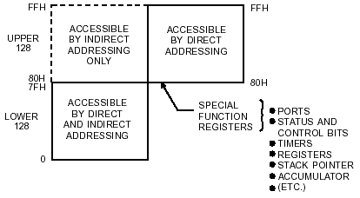

Internal data memory addresses are always 1 byte wide, which implies an address space of only 256 bytes. However, the addressing modes for internal RAM can in fact accommodate 384 bytes. Direct addresses higher than 7FH access one memory space, and indirect addresses higher than 7FH access a different memory space. Thus, Figure 7 shows the Upper 128 and SFR space occupying the same block of addresses, 80H through FFH, although they are physically separate entities.

Scratch Pad RAM Organization
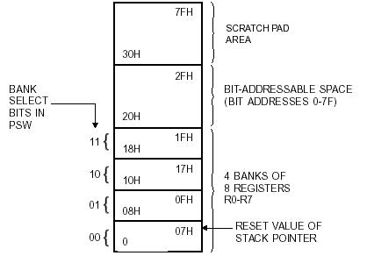
Figure shows how the lower 128 bytes of RAM are mapped. The lowest 32 bytes are grouped into 4 banks of 8 registers. Program instructions call out these registers as R0 through R7. Two bits in the Program Status Word (PSW) select which register bank is in use. This architecture allows more efficient use of code space, since register instructions are shorter than instructions that use direct addressing.

The 128 Byte Memory
The next 16 bytes above the register banks form a block of bit-addressable memory space. The microcontroller instruction set includes a wide selection of single-bit instructions, and these instructions can directly address the 128 bits in this area. These bit addresses are 00H through 7FH. All of the bytes in the Lower 128 can be accessed by either direct or indirect addressing. The Upper 128 (Figure 9) can only be accessed by indirect addressing. The Upper 128 bytes of RAM are only in the devices with 256 bytes of RAM.

The SFR
Figure gives a brief look at the Special Function Register (SFR) space. SFRs include Port latches, timers, peripheral controls, etc. These registers can only be accessed by direct addressing. In general, all Phillips microcontrollers
have the same SFRs at the same addresses in SFR space as the AT89C51 and other compatible microcontrollers. However, upgrades to the AT89C51 have additional SFRs. Sixteen addresses in SFR space are both byte- and bitaddressable. The bit-addressable SFRs are those whose address ends in 000B. The bit addresses in this area are 80H through FFH.

